

Lab 6

Firewall Lab- pfSense Setup

ITSC 206: Advanced Networking for Offensive and Defensive Environments

Table of Contents

Lab Setup 2

Files/Download 2

Reading 2

Introduction 2

Initial Firewall VM Setup 2

Firewall VM Setup 6

Extra Kali Setup 23

Lab Setup

* Review architecture for each configuration and optimize.

Files/Download

Reading

* [https://doc.pfsense.org/index.php/Installing_pfSense#](https://doc.pfsense.org/index.php/Installing_pfSense)

Introduction

This document supports the setup of Lab6 firewall.

Initial Firewall VM Setup

Setup pfSense with the following attributes in the VM Player:

1. New Virtual Machine

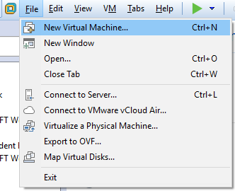

1. Build from eval ISO (C:\Temp directory) (pfSense-CE-2.4.2-RELEASE-amd64.iso)

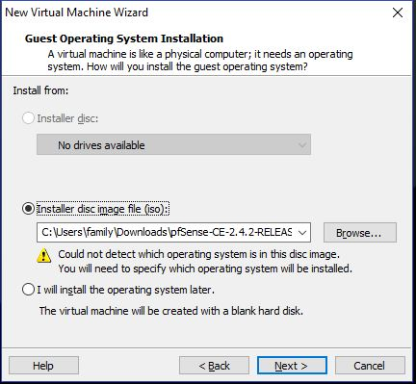

1. Name of Virtual Machine: pfSense within VM into C:\Virtual Machine folder so everyone to use it

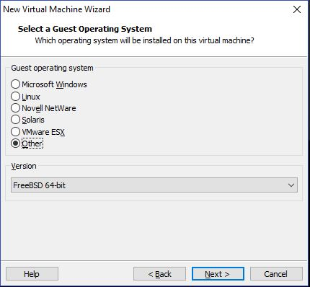

1. Using 20 GB Hard disk

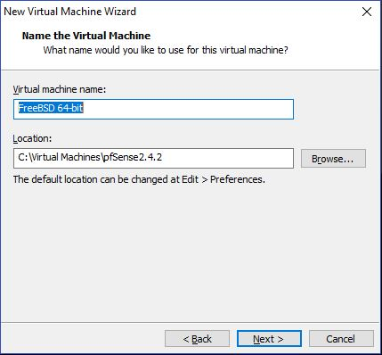

1. Using 20 GB Hard disk

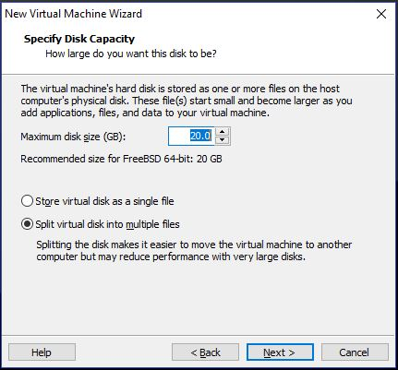

1. Click on Customize Hardware button to change the VM

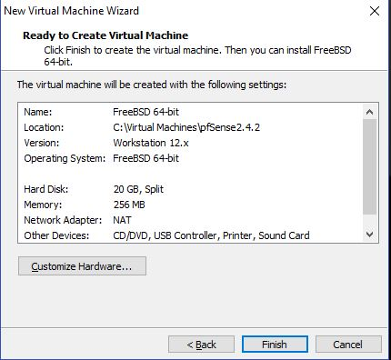

1. Change to 1 GB of Ram, 1 CPU, 2x Network Adapter (LANSegment1, LANSegment2)

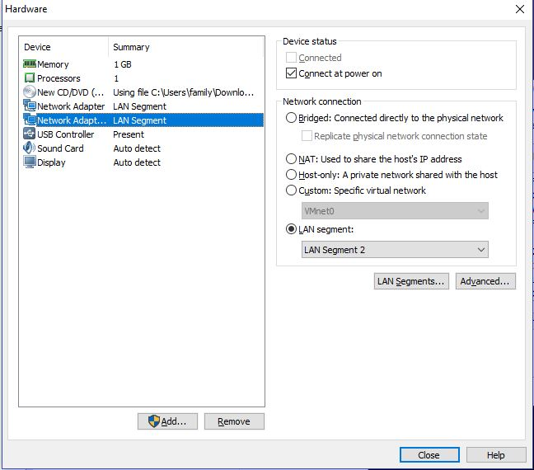

1. After review of info, appears to be accurate, click on Finish

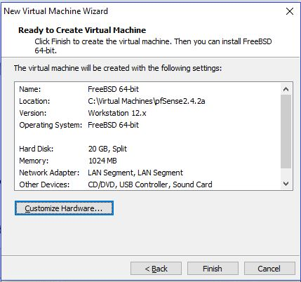

Firewall VM Setup

Setup pfSense with the following attributes in the VM Player:

1. Start up VM server in VM Player, press 1 or let auto boot occur

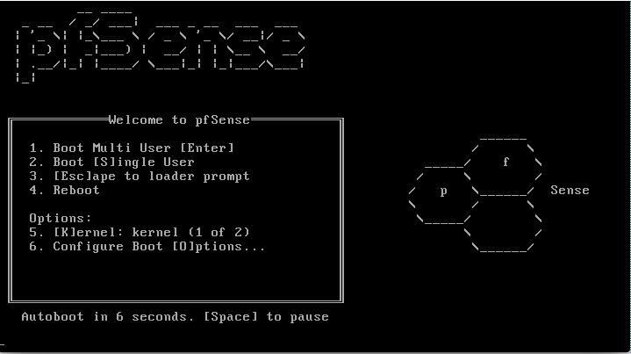

1. pfSense Installer Accept

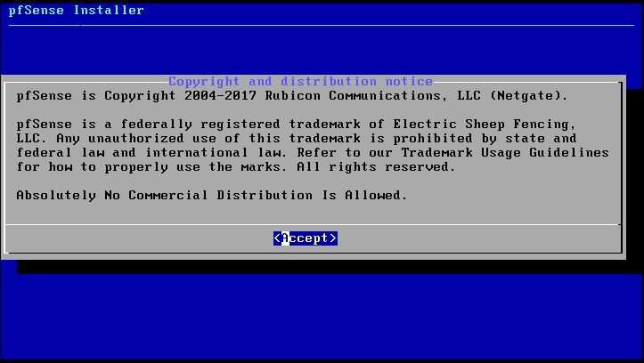

1. pfSense Install, press OK

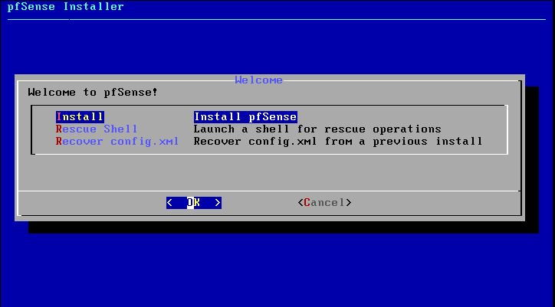

1. pfSense Installer, Keymap selection accept

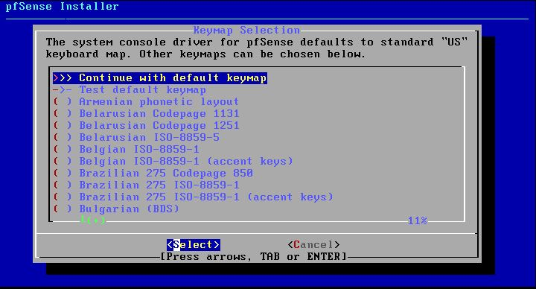

1. pfSense Installer disk partitioning, press OK

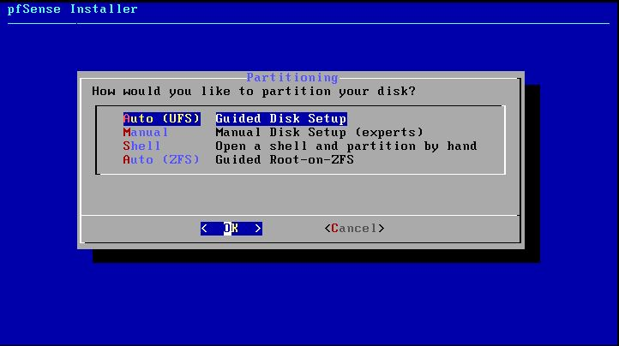

1. pfSense Installer, Extracting distribution files

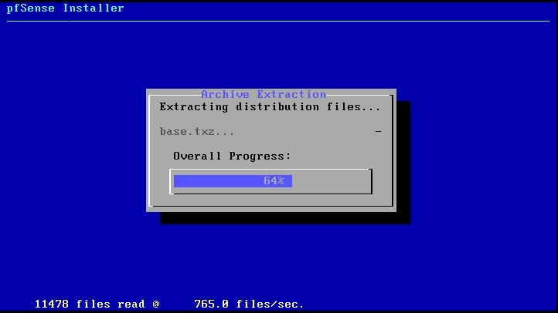

1. pfSense Installer, Manual Configuration, press No

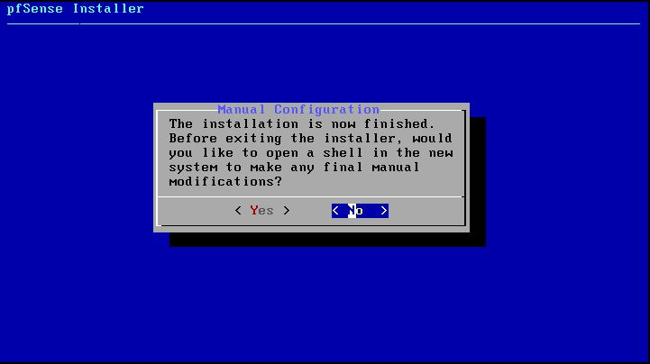

1. pfSense Installer, Complete press Reboot

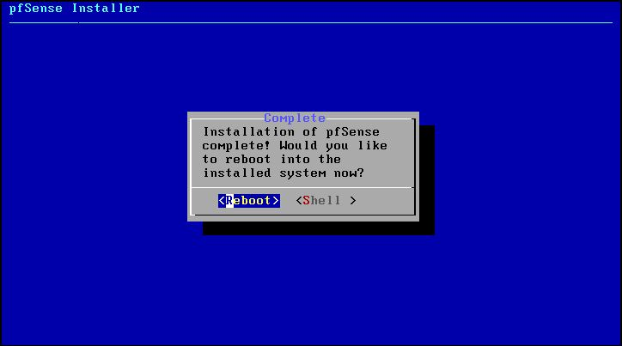

1. pfSense, boot in multi user in 6 seconds



1. pfSense setup, Option 2, set interface

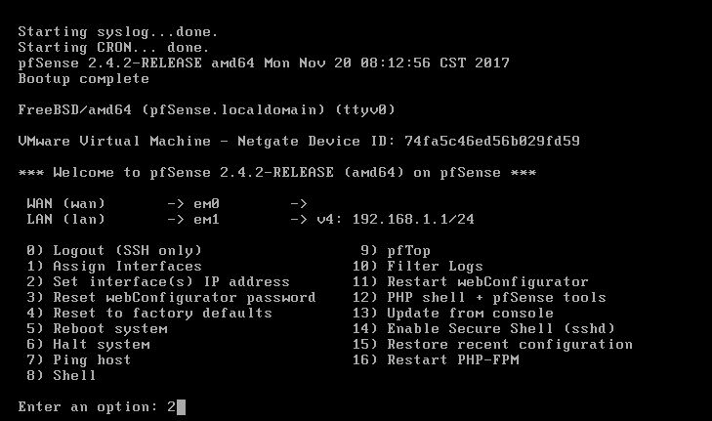

1. pfSense setup, available interfaces: 1, WAN IPv4 address: 172.16.4.1, subnet mask: 24

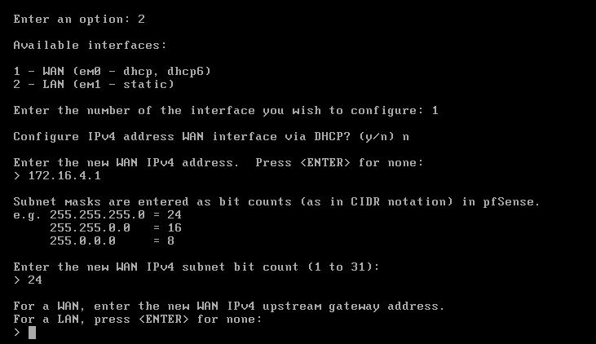

1. pfSense setup,IPv6 DHCP: n, IPv6 address: <ENTER>

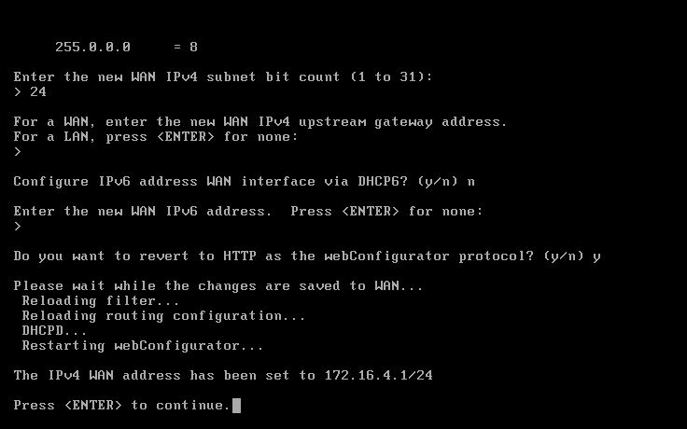

1. Notice LAN & WAN interface and IP address

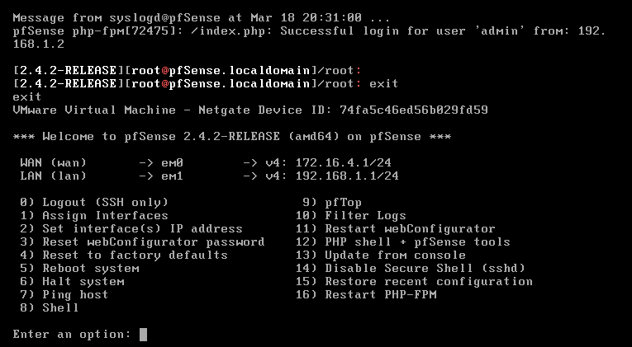

1. Enter shell and review interfaces

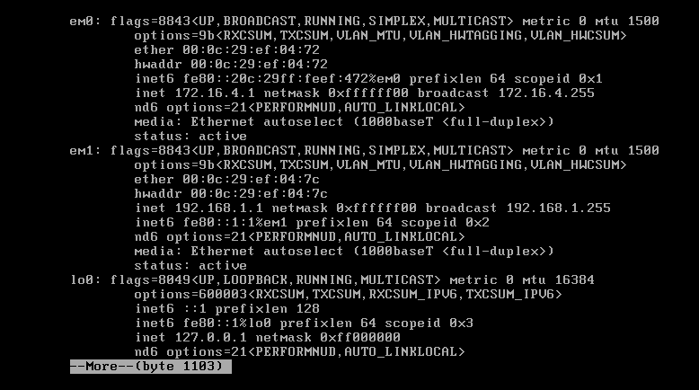

1. Once Web server is up and can ping the LAN interface of the pfSense Firewall, then use Firefox to <http://192.168.1.1>, login using default admin/pfsense

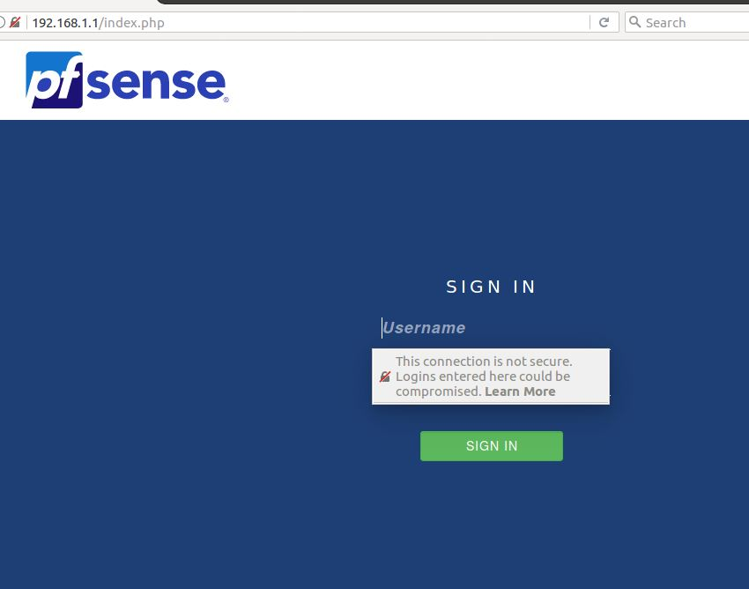

1. pfSense Firewall setup, press Next

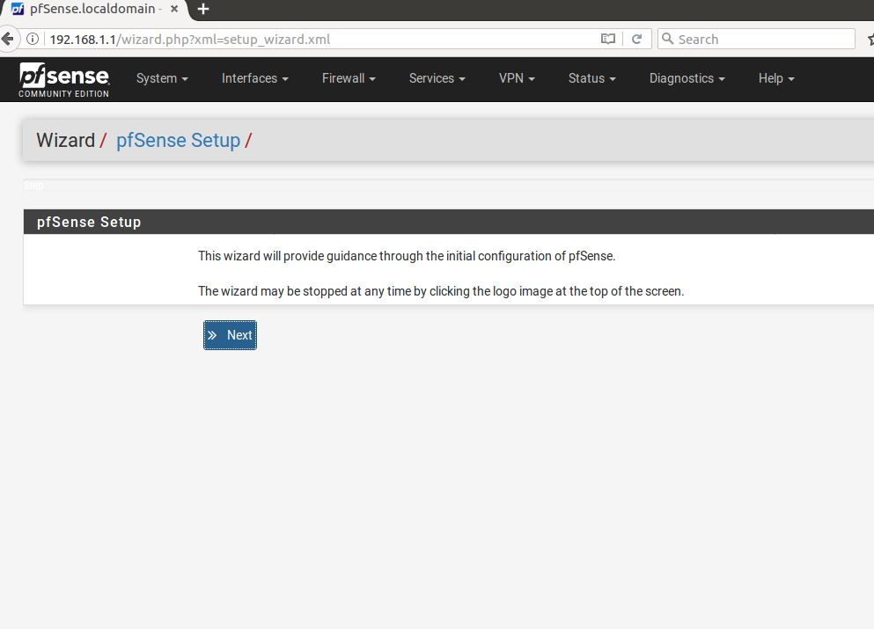

1. pfSense Firewall setup, Netgate Gloabal support, step 1 of 9, press Next

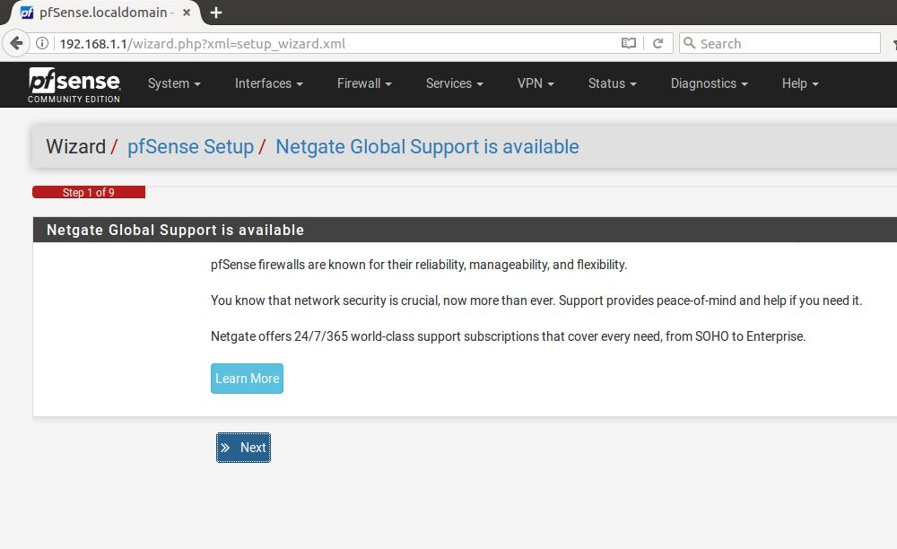

1. pfSense Firewall setup, General information, step 2 of 9,

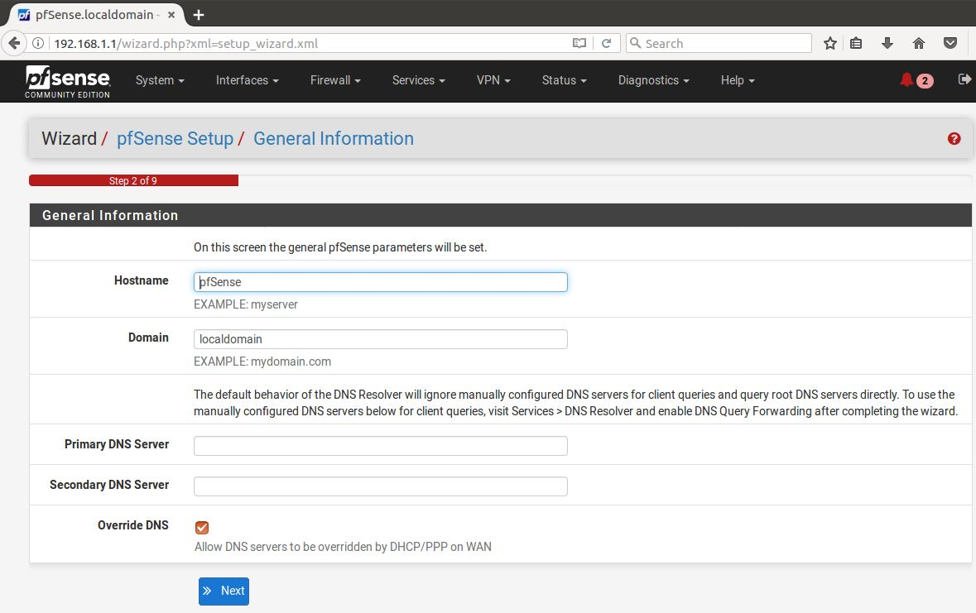

1. pfSense Firewall setup, Time server, step 3 of 9, press Next

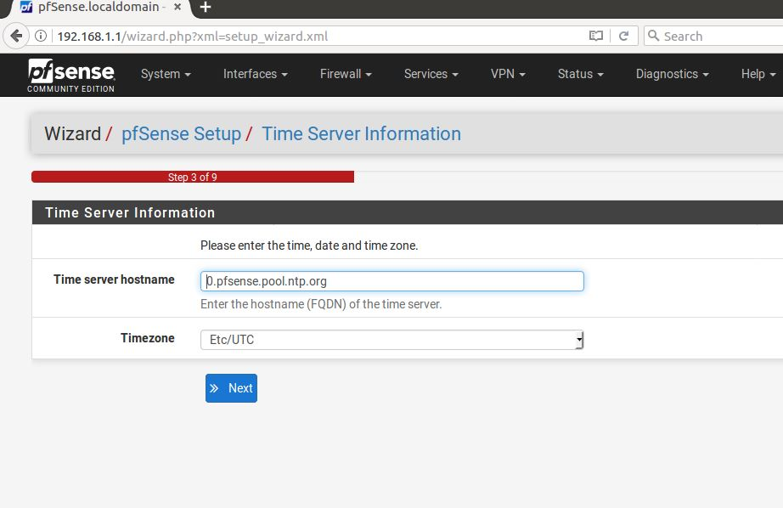

1. pfSense Firewall setup, Configure WAN interface

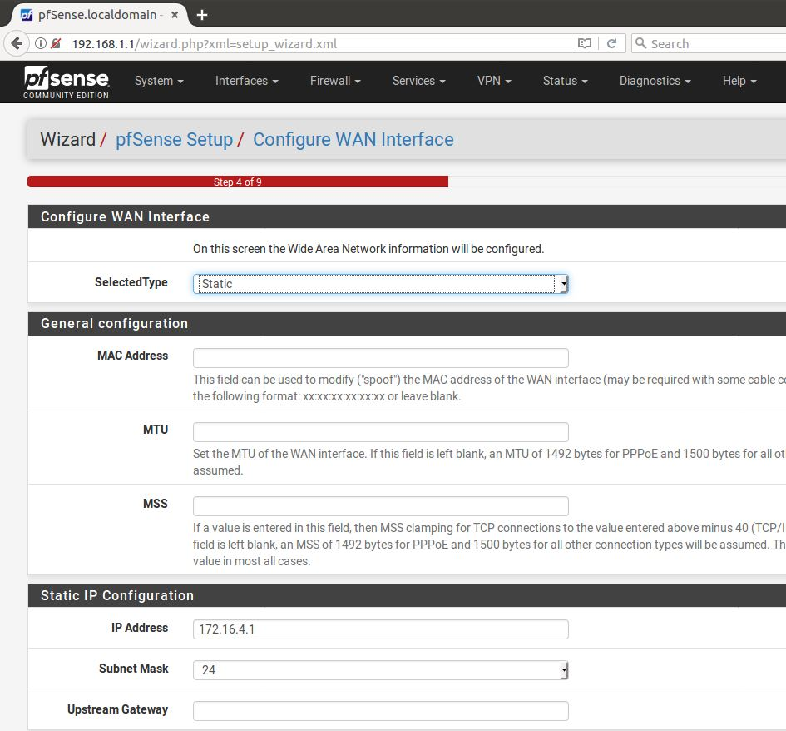

1. pfSense Firewall setup, Configure WAN interface

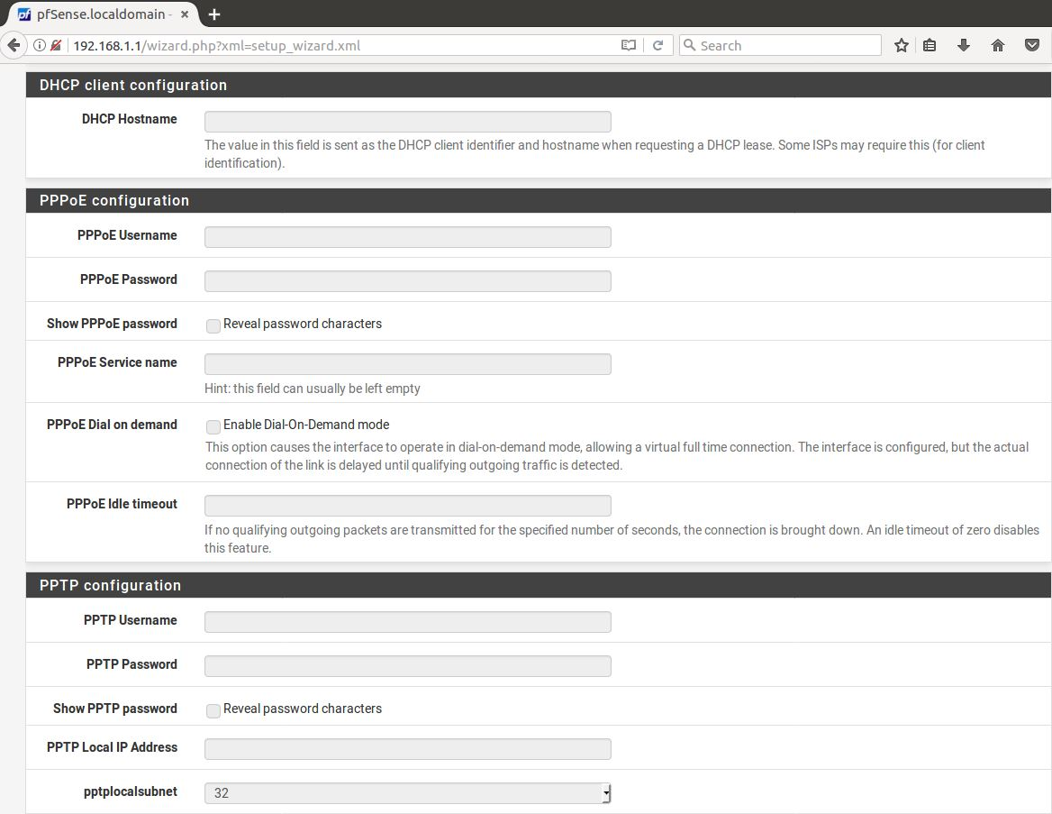

1. pfSense Firewall setup, Configure WAN interface , press Next

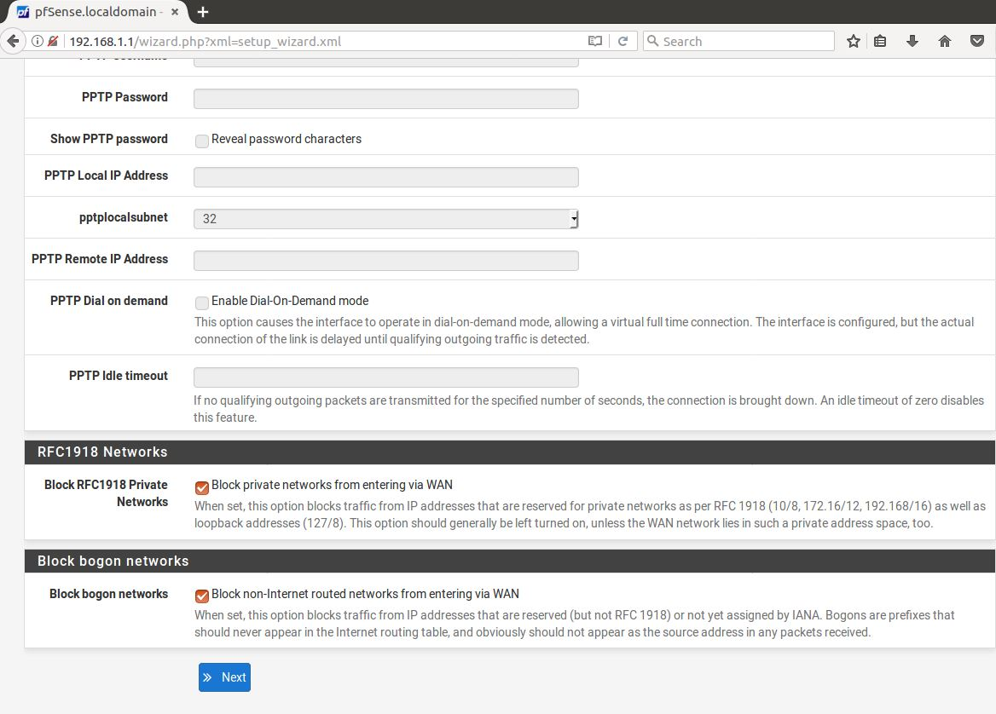

1. pfSense Firewall setup, Configure LAN interface, press Next

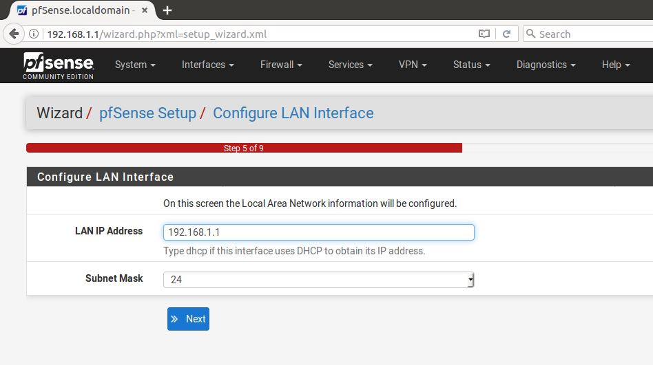

1. pfSense Firewall setup, Set Admin WebGUI Password, press Next

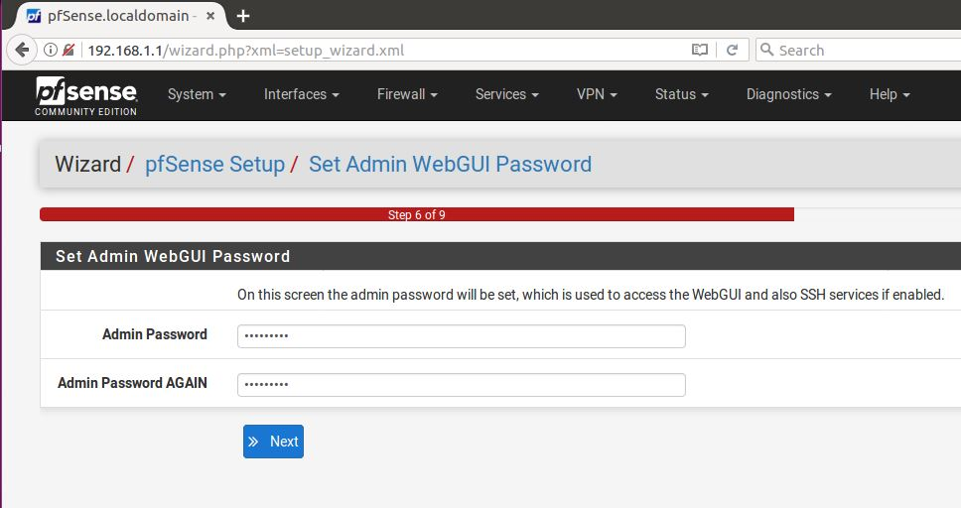

1. pfSense Firewall setup, Reload configuration

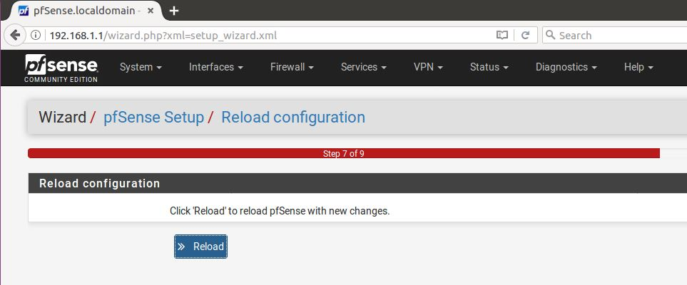

1. pfSense Firewall setup,

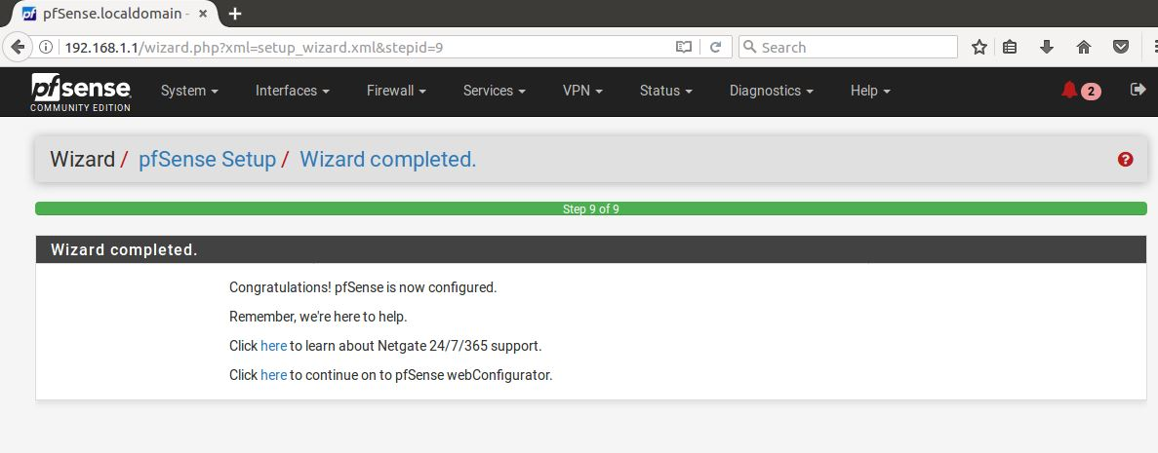

1. pfSense Firewall Status Dashboard,

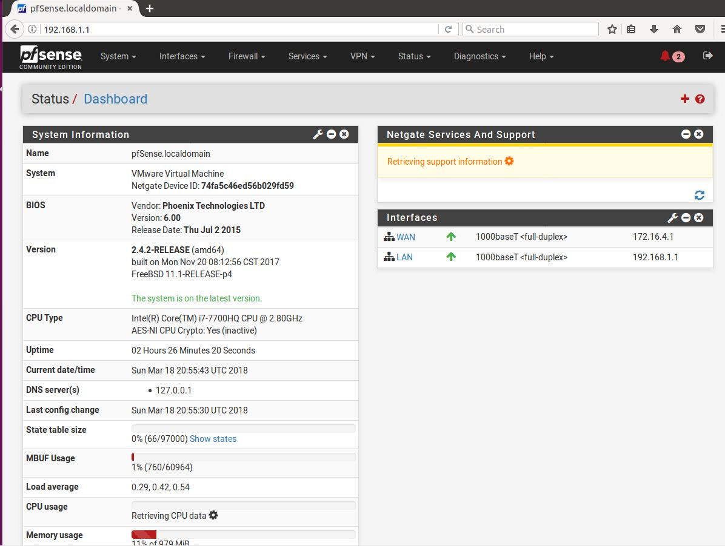

1. pfSense Firewall, Firewall Rules

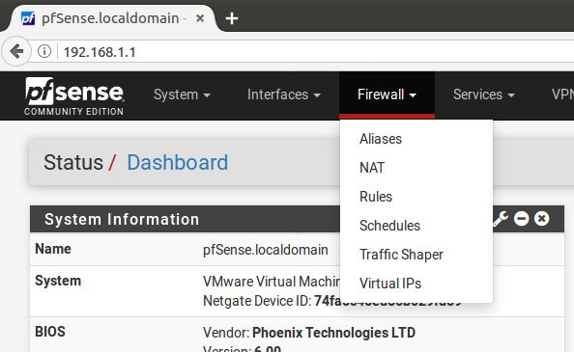

1. pfSense Firewall NAT,

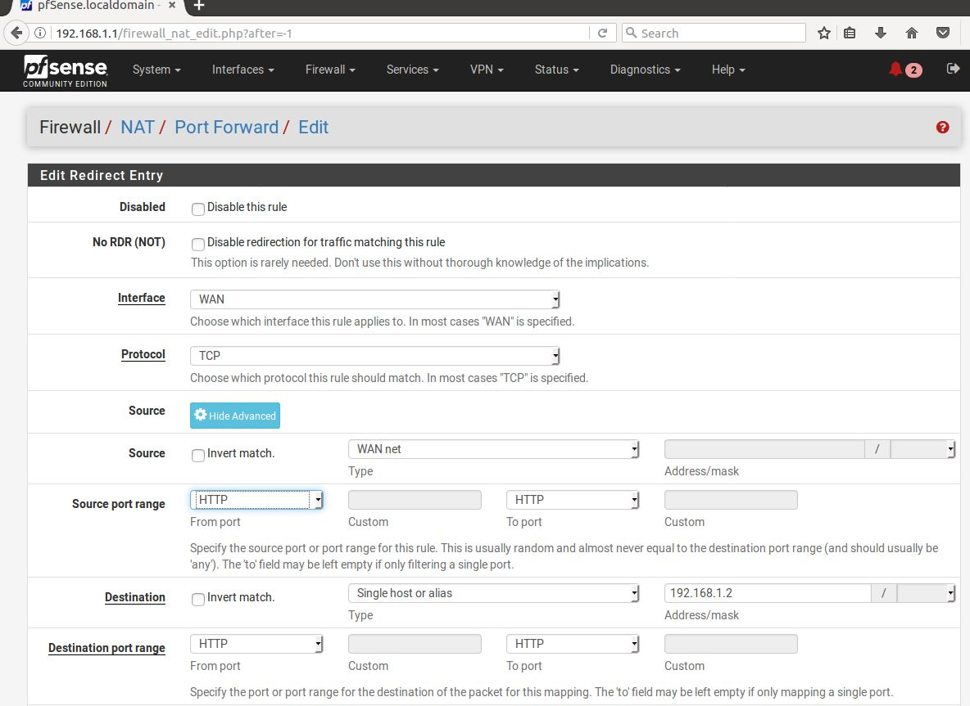

1. a

Hints:

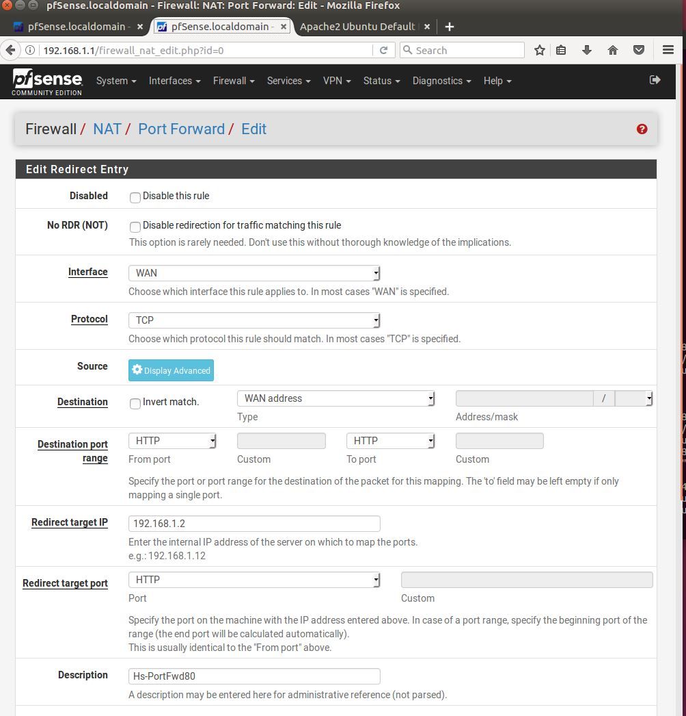

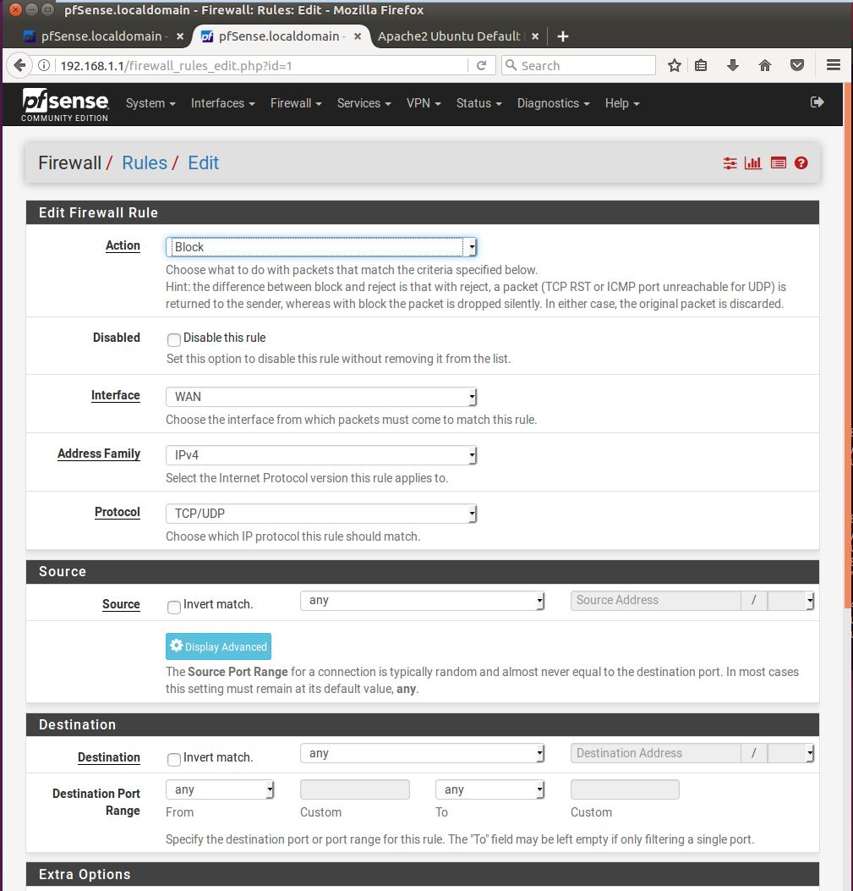

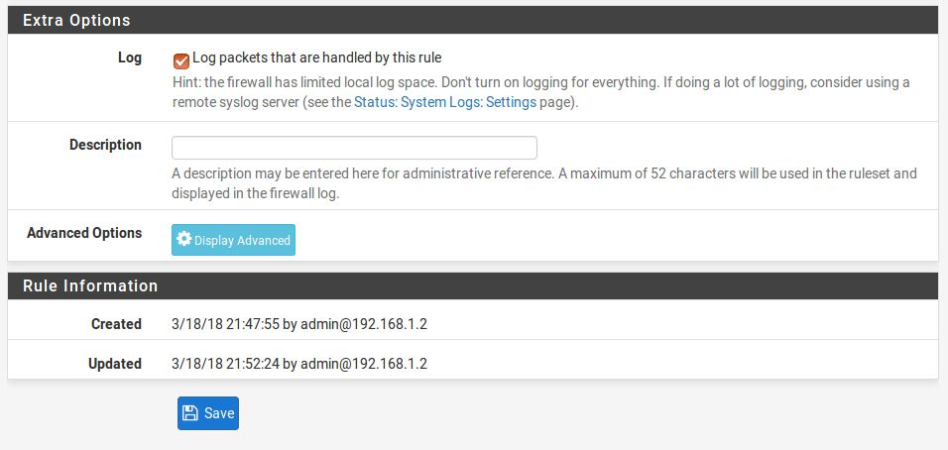

# Extra Kali Setup

1. If it doesn’t already have set up a Kali workstation in a VM using ISO with the following parameters:

* 2 CPU
* 4 GB of RAM
* 80 GB HDD
  1. Install an Kali by entering the following commands:
  + sudo apt install openvas
  + sudo openvas-setup
  + openvas-check-setup

**DO NOT DELETE THE SECTION BREAK BELOW. DELETING IT MAY IMPACT THE FORMATTING IN THIS DOCUMENT.**